Introduction
The data synchronization will be taking place between Calgary and Quito and will involve two specific data moves; one being online geophysical data from SeisWorks (data associated with ORIENTE56) and the second being the Oracle data (ORIENTE56).

These data moves / workflows will be described in this document and will be used for intermittent data transfers and not the full data synchronization as previously discussed.

The first workflow will detail the geophysical data move. This will involve using UNIX and an online script.

Transfer ID
In order to have consistency in both offices, with regards to data ownership, a new UNIX login id has been set up. All data transfers should take place using the datatran user id that has been created in both offices. Please log into a UNIX box that is connected to the current Landmark Oracle instance using the datatran id. The login password for the Calgary datatran id was sent to you by Deirdre Newman in an e-mail on Friday, June 20, 2003. For information on any datatran password updates please contact Lorraine Bellerive in Calgary or Diego Penafiel in Quito.

Online Data Backup

Step 1: Backing up the SeisWorks Data

Launch OpenWorks on your screen. Once the OpenWorks menu is on screen, click on System → Unix Window. This will open an xterminal window that has Landmark environment variables set.

Within this xterminal, verify that the $OW_PMPATH variable is set up in the environment before you run the scripts. Type:

echo $OW_PMPATH

If it returns with an undefined variable message it needs to be set as:

setenv OW_PMPATH /apps01/landmark/conf (in Quito)
or
setenv OW_PMPATH /intl/ecuador/d1/confR2003 (in Calgary)

Within another UNIX xterminal window, use the cd command to go to the directory where the data is going to placed.

cd /data/transfer/CALGARY (in Calgary)
or
cd /data/transfer/QUITO (in QUITO)

If multiple SeisWorks projects are going to be backed up it is suggested that a subdirectory be created for each project. To create the subdirectory in the above directory type:

mkdir <folder name>

Now, once again, in the Landmark xterminal, when you set the $OW_PMPATH variable, you can see what is required to run the backup script for the online SeisWorks data by cd’ing into the following directory:

cd /home/encana/startup/intlR2003 (in Calgary)
or
cd /data/transfer/scripts (in Quito)

Once you are in this directory, type:

./SeisWorks_Backup_Sync.sh

By typing this, you will get a result similar to the following:

SeisWorks_Backup_Sync script has required inputs

usage: SeisWorks_Backup_Sync <EnCana Region> <Backup Time Period Days)> <Backup Location> <optional - OpenWorks Project> <optional - SeisWorks Project>

EnCana Region ------> Enter a valid EnCana International Region
Enter DEFAULT if backup region not known. Entering
DEFAULT will back up currently active Landmark Project
Management environment

Backup Time Period -> Enter a positive Integer value
All files modified during Backup period specified will
be backed up

Backup Location ---> Valid Backup Staging Area Directory Location

OpenWorks Project --> Only Backup SeisWorks project data affiliated with
OpenWorks project
Entered. This parameter is optional. If not entered all
SeisWorks projects will be backed up

SeisWorks Project --> Only Backup Time Based changes to SeisWorks Project
Required.
The Project must be affiliated with specified OpenWorks
Project. This parameter is optional.

An additional option of selecting data that has been altered by a specific interpreter has also been added to this script. Using this option, you can select UNIX usernames to extract data from a file system. This option will only extract 3D horizon data after the associated horizon header has been updated by the selected interpreter.

The usage statement describes that you must add in the additional information denoted by the <> brackets, filling in the actual information that the script requires for the backup. If you do not add in the proper information following the script name, the script will return errors. You do not have to add in the information that is denoted as optional in the script usage description.

For an example, to back up all of the SeisWorks project data for a period of 7 days, writing the results to the /data/transfer directories, the script would be typed as follows:

/data/transfer/scripts/SeisWorks_Backup_Sync.sh DEFAULT 7 /data/transfer/QUITO ORIENTE56 (in Quito)
or
/home/encana/startup/intlR2003/SeisWorks_Backup_Sync.sh ecuador 7 /data/transfer/CALGARY ORIENTE56 (in Calgary)

The file name will be output automatically from the script, there is no need to specify an output file name when selecting a directory for output.

Within the Quito office, since no formal business units exist within the Landmark configuration, the option of DEFAULT is used for the EnCana Region portion of the script.

**NOTE: Make sure that you choose an output directory that has enough space in order to write the file. If you suspect that the file is greater than 2 gigabytes in size, make sure that you are writing to online disk that can support large files. To check to see which system directories are of this nature, type:

mount

The directories that can support large files will show a “largefiles” flag in the directory definition. Those specified as “nolargefiles” will not support files greater than 2.1 gigabytes in size.

Step 2: Transferring the SeisWorks Backup Data File to the Other Office

Once the backup file is created check on the size of the file. In the output directory type:

ls –l

Transferring Data to Tape

If the file is large (1 to 40 gigabytes) you will want to write this data to a tape. To write the data file to a tape, make sure that you are on a machine that has a tape drive attached or that you can log into this machine by typing

rsh <machine name>

The tape device on this machine may be defined differently, but the standard directory setup for a DLT tape device on a Solaris machine is /dev/rmt/0. Check with the person who configured the tape device or check the tape device itself since the tape device configuration is often labeled on the physical tape drive. Alternatively, you can access the available system tape drive names by cd’ing into the device directory on the machine. Type:

cd /dev/rmt

and do a listing to see the available tape drives.

Insert a DLT tape into the tape drive. Some tape drives have certain procedures for inserting a tape, while with others, you simply insert the tape and then push down the flap above the tape insertion slot. Have a person familiar with using the tape drive show you how to use it properly. Once the tape is inserted into the drive, wait a few minutes for the green ready light to stop flashing. This will indicate that the tape drive is ready to use. Type:

mt –f /dev/rmt/0 rewind (for example, if this is the name of the tape drive device)

This will rewind the tape to the beginning (often the tape insertion will also do this job) or will give you an error that it cannot find or read the tape drive. If you receive an error, check to make sure that you have typed the tape device specifications properly (/dev/rmt/0) and have inserted the tape correctly into the machine.

Once you have made any necessary corrections, retype the mt –f command above, or with necessary changes, until you do not receive any errors and the command simply returns the cursor to a UNIX prompt.

Once this has worked successfully, type:

tar –cvf /dev/rmt/0 /data/transfer/QUITO/<filename>

or

tar –cvf /dev/rmt/0n /tmp/<filename>

if multiple files are going to be added to the same tape. The n is for the no rewind option. Once the first file is completely transferred to tape, you can retype this command for the second and other successive files. This will make sure that each file is written to tape at the point on the tape where the last file finishes.

This command tells the computer to create a tar file on a tape drive called /dev/rmt/0 for a file within the tmp directory called <filename>. You will have to replace <filename> in this command with the actual name of the output file.

Once this process has begun, wait until both the green light on the tape drive stops flashing and the command returns a new prompt. When this has happened, it is safe to remove the DLT tape from the tape drive or add the next file to the tape.

Label this tape detailing the date of the backup, type and name of file, and indicate that a tar command that was used for the backup. Set the tape to be write-protected before transporting it between offices. Do this by following the instruction notes with the DLT tape case (physically switch the write protector tab to the ‘do not overwrite’ position).

If the backup is greater than 40 gigabytes, the backup onto tape may span over more than one DLT tape. If this is the case, you must use a different tar command (gnutar) that is similar to the above but looks like:

/usr/local/bin/tar –cvMf /dev/rmt/0 /tmp/<filename>

Typing the /usr/local/bin directory before the tar command tells the system to run the specific tar command that resides in this directory. The M in this command allows for spanning across multiple DLT tapes. When you are removing these tapes from the tape drive, make sure that you label them in sequence (1, 2, 3…) and write-protect each tape.

**NOTE: If the files have been written to tape, it is a good idea to write down the original file sizes and take this information with you or send it to the person who will be doing the data extraction.

Transferring data using file transfer protocol (ftp)
If the backup is less than 1 gigabyte, you may choose to ftp the data to the other office. To do this, make sure that you are in an xterminal in the directory where the file resides (example, cd /tmp). Type:

ftp <machine name>

For example to ftp from the Calgary office to Quito you can type:

ftp ECQULM001

or to ftp from the Quito office to Calgary you can type:

ftp ftp.encana.com

Once you have ftp’d to the machine, it will ask you for a username and password. Log in using the datatran id with the password from the other office. Alternatively, you can use your UNIX username and password from the other office where the machine that you are ftping to exists.

For Calgary, you can use the location /data/transfer/Calgary and in Quito, use the location /data/transfer/Quito. Use the cd command in the ftp window to go the appropriate directory path by typing:

cd <directory path>

When you are in this directory, check the disk space in this file system to make sure that you have enough space by typing:

df –k .

To transfer the file more quickly, in binary mode, type:

bin

**NOTE: If you are transferring Oracle (OpenWorks) project files using ftp, you must type the command bin before doing the data transfer. Otherwise, the restore of the OpenWorks project will not be successful at the other office.

To start the file transfer type:

put <filename>

Once the transfer is complete, it will output a file size to the screen. Make sure that this file size matches that of the original file being transferred by typing:

dir

within the ftp window.

Within another xterminal window, cd to the directory where the original file exists and type

ls –ltr

to get the file size to display on screen. If the file sizes are not the same (file size of the transferred file is smaller than the file size of the original file) or if the transfer was aborted, you should try the transfer again, possibly during non-business hours or transfer the data to tape. To transfer it to tape, please follow the procedure written above in the section “If the file is large (1 to 40 gigabytes)”.

The exit ftp type:

bye

or

quit

Online Backup Assumptions:
There are several assumptions that are made during this process by using the above scripts. They are as follows:

- The Backup Utility will only backup SeisWorks project data
- The Backup Utility must be run in a valid Landmark R2003 run time environment
- The Backup staging area must have enough disk space otherwise it will fail.
The error logs will flag the problem. Keep in mind large Backup windows
(2 to 3 weeks) may require large online disk staging areas.
- The final result of the Backup process is a compressed tar ball stored on line
in the designated staging area
- Backup Utility parameters required at invocation time are:
  - EnCana Project Management Region
  - Backup Time Period (Days)
  - Backup Staging Location
  - OpenWorks Project (Optional Parameter)
  - SeisWorks Project (Optional Parameter)
- All temporary SeisWorks project files which have been modified in the backup
time period will not be captured as part of the backup process. These
temporary files include the tmpcgm, tmp.F*, hzbf*, *.inp, v8*, *.cgm and the 3D
horizon header and 3D horizon files.
- A multi horizon export will be conducted on all SeisWorks 3D projects whose
horizon header has been modified within the Backup time period. The export
results will be stored in a file named horizons_BCK.dat and will be included as
part of the Backup process. The EnCana Quito office must download the Multi
Horizon Export utility (mltexp_SunOS) if it is not already in place.
- Strict guidelines must be established to define the Backup Time Period between the EnCana Calgary & Quito offices properly so no SeisWorks project changes are missed.
- The backup and restore scripts must be the latest version in both the source and target offices at the time of backup / restore in order for the data transfer to work properly.

Backing Up the Oracle (OpenWorks) Data

Procedure

For the OpenWorks data backup, we will be using a utility known as PDT (Project Data Transfer). PDT will look at the database and will be able to capture time-stamped data, for example, data from the last 7 days, for backup. The types of data that can be transferred using PDT are:

Basin Data / Field Data / Lease Data / Facility Data / Well Data / 2D Seismic Navigation Data / 3D Seismic Navigation Data / SeisWorks Fault Data / Stored Queries / Strat Column Data / Interpretation Data / Line of Section Data / Well Template Data / List Data / Well Planning Project Data

Essentially, you will be creating a temporary project for the data transfer, copying time-stamped data from the existing OpenWorks project (ORIENTE56) to this temporary project, backing up this project and transferring this backed up project, either by DLT tape or ftp to the target office.

Alternatively, you can do a full backup of the OpenWorks project from the source office and use this time-stamped portion of the workflow (Section 4) to transfer only the data needed into the OpenWorks project at the target office. You may want to consider this option if you are pressed for time to get the Oracle backup generated since the PDT process takes longer. IF YOU DO THIS, PLEASE COMMUNICATE THAT A FULL BACKUP OF THE ORACLE PROJECT HAS BEEN TRANSFERRED TO THE PEOPLE DOING THE RESTORE IN THE TARGET OFFICE.

**Please also communicate this information by updating the data transfer document(s) in Livelink.

Step 1: Creating a Temporary OpenWorks Project

To create the temporary project, launch Project → Project Admin from the OpenWorks launcher menu. Select the project that you want to backup from the list so that it is highlighted. Click on Project → Modify…, and leave this dialog box on the screen. You will have to have Manager status in the project in order for this dialog box to display.

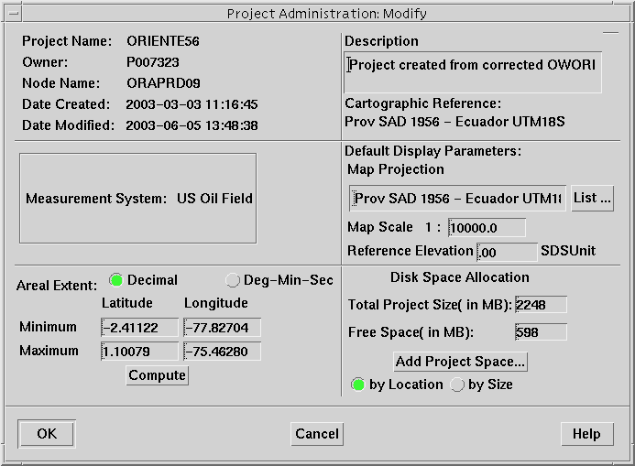

Go back to the OpenWorks menu and click on Project → Project Create. Within the Project Create dialog box and in the box underneath where the words “Project Name” exist, type in a name for the temporary project such as:

TRANSFER_O56_<current date>

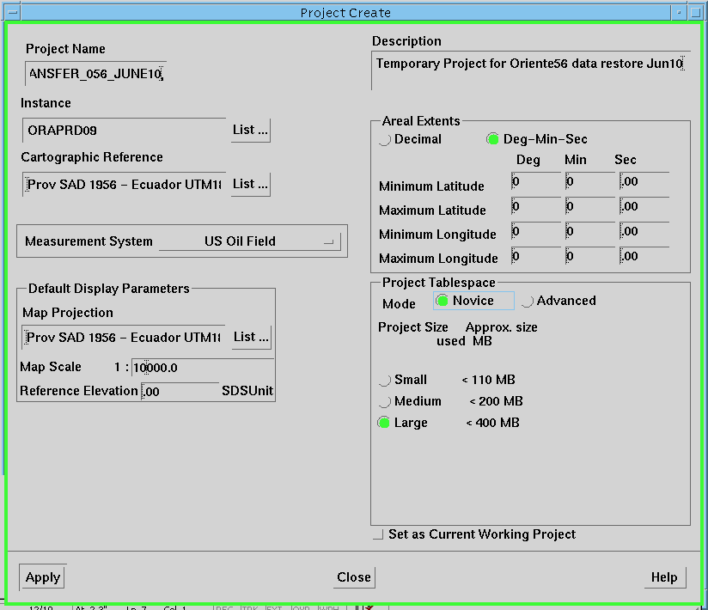

To fill in the “Cartographic Reference” box, refer to the Project Administration: Modify dialog box and make sure that you select the same Cartographic Reference System (CRS) for the target project as the source project. To set this CRS for the target project, within the Project Create dialog box, click on the List…key beside the blank area underneath the words “Cartographic Reference”. This will open the CS Selection dialog box. If the project is using a UTMX and UTMY coordinate system definition, which is normally the case, then use the left side of this dialog box to select the CRS. Under the words “Projection Coordinate System”, find the CRS of the source project. Highlight this CRS and click OK.

Beside the words Measurement System, click on the words US Oil Field which will open up a drop-down listing of all available measurement systems. Again, refer to the Project Administration: Modify dialog box and make sure that you set the same measurement system in the target project that you have in the source project. You can do this by sliding your cursor over the options in the drop down selections, until the appropriate one is highlighted and then release your cursor.

Do not worry about filling in the Project Extents; this will be computed automatically as soon as you move data into the project. Under the Project Tablespace section, leave the Mode as Novice and then click on an estimated project size (for ORIENTE56, choose >400 mbytes). When you have all of this information filled in, click on Apply. The program will ask you if you would like to continue with the project creation process. Just click on Continue.

This will start off the project creation process for your new OpenWorks project. Once this process is complete, the process will tell you so and you can then click Close on the window.

**NOTE: Do not stop or abort the project creation process while it is running, even if you are aware of a mistake that has been made in the setup parameters. Just let the process run to completion and then any unwanted OpenWorks projects can be removed after the fact.

Step 2: Setting Create Dates to Update Dates in the OpenWorks Database

To make sure that all data is captured from the source project using the Project Data Transfer (PDT) utility, it is necessary to do this step. Since this utility reads the update_date portion of each Oracle table in the OpenWorks project and the update date is NULL until a user alters any newly created data, it is necessary to fill in all newly created data pieces with a date in the update_date field.

To do this, I have put together a series of one-line scripts that must be run using SQL. SQL is a computer language that is used to work behind the scenes in Oracle. To use SQL, please follow these instructions implicitly since risk is involved in changing data using SQL.

To run SQL, you must be a project Manager for the OpenWorks project that you are using. Type:

ow_prj_access ORIENTE56

This will provide you with the SQL project password to log into sql. You must be a project Manager to run sql. When the OpenWorks project name is returned to you, highlight the portion of the line with the OpenWorks project name and all other information just to the end of that line. Type:

sqlplus <highlighted information using MB2 to paste>

This will bring an SQL prompt to the window. Within SQL, you will be highlighting and dropping lines from a file that I have created. The file name for this file is Update_scripts.sql. Open an xterminal by right-clicking (MB3) and highlighting the option New Window – xterm. This script is currently sitting in the following directory paths in Calgary and Quito and you can go to this directory by typing the following within the xterminal window that you just opened:

cd /wrk1/is/p007323/QUITO/DATA_SOLUTIONS (Calgary)
or
cd /data/transfer/scripts (Quito)

Open this file to your screen by typing:

nedit Update_scripts.sql &

The ampersand in this command allows you to continue to work in the terminal window in case you need this functionality.
Leaving this file up on screen, highlight the first set of about 20 lines so that the entire last line is highlighted (I have included gaps in the file so that you know approximately how many lines to highlight). Once the lines are highlighted, drop them into the xterminal where you are running SQL by using the second mouse button. Using some xterminal windows, depending on your shell settings, you may have to click on the window where SQL is running first, before dropping the highlighted lines within the xterminal. You will likely be familiar with your xterminal settings work before you get to this point of the workflow.

After you drop the highlighted lines of text from the Update_scripts.sql file into the SQL xterminal, SQL takes this information and processes each line, replacing the null update_date fields with the existing create_date fields.

If this section runs successfully, without error, type:

commit;

If it does not run successfully, type:

rollback;

and select fewer highlighted lines for the next run. Make sure that you give SQL enough time to run through all of the lines before continuing or typing commit. If there are many database updates to do, the script lines may not complete instantaneously.
Work through the entire Update_scripts.sql file, highlighting each section and dropping the lines into the SQL xterminal window, until the entire file is complete and typing commit after every successful update.

Make sure that after you are finished this process that you exit SQL. You can do so by typing:

quit

at the SQL prompt.

SQL is a very powerful database language and you can corrupt the project by forcing commands that you do not fully understand. Please be awake and aware when running any scripts using SQL!

Step 3: Using Project Data Transfer (PDT) to Create a Subset of Data

To transfer data from ORIENTE56 to the new TRANSFER_O56_* OpenWorks project (that you created in the last step), you will be using a utility known as PDT (Project Data Transfer). To launch the correct version of PDT that allows you to set up parameters to capture time-stamped data, you will want to do the following. Open up a Landmark xterminal by clicking on System → Unix Window. Type the following in this xterminal window:

pdt –a

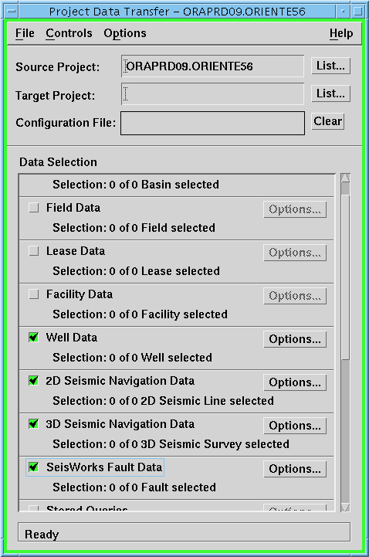

This PDT dialog box will look different from the original dialog since it has a third box at the top that allows you to enter a Configuration File name. To set up PDT, once this dialog box is open, select the source project, such as ORIENTE56 and then your target project, TRANSFER_O56_*. A message will pop up letting you know if the source project overlaps the target project extents. Just click on the OK button to remove this dialog from the screen. Setting the project name information in the dialog box will allow you to work through to select other items.

The most important step in the PDT transfer is to select the start and end dates and times for the transfer so that they are relevant for the period of data creation and updates that you are planning to send to the other office. You want to make sure that you capture data from the time of the last data synchronization and that you do not miss data in the process. **This information should also be recorded in a central location to both offices so that the information is relayed and available during data transfers.

To set the start and end times for OpenWorks data capture, click on Options → Global Advanced Filters. Leave the Create New Data option toggled on. Set the “Transfer data with update timestamps” option to on. Fill in the from - to fields to identify what information should be captured during the data transfer.

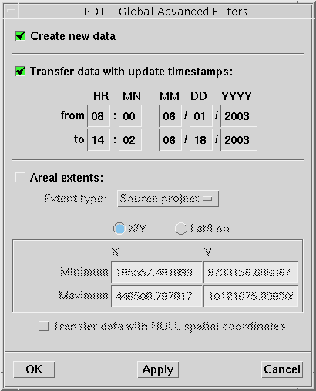

It is not necessary to set an areal extent for the project, unless you need to transfer data that has areal limitations.

Once you have filled in the timestamp information, click on OK at the bottom of the dialog box.

Go again into Options and now select the Global Transfer Options. For our purposes, toggle on the Overwrite data in target, leave the Validate source coordinates and toggle on the Force transfer on conversion error. Leave everything else in this dialog box toggled off and click OK.

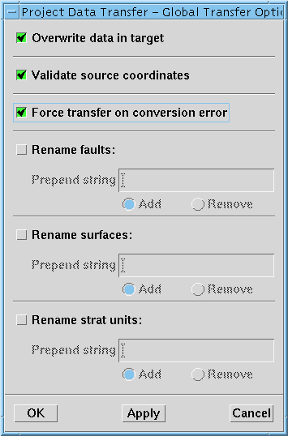

Other important things that need to be tracked are any transfer reports or errors. These are generated automatically, but if you want to control where the file is going or would like to change the output file name so that any successive PDT runs do not overwrite existing report files, go to Options and select Set Transfer Report. As you can see, this report automatically writes out to your home directory with a file name of pdt.report. You can change the name to include a date stamp or change the directory to a central data transfer directory so that both offices can see the effect of the data transfers. Leave Errors, Warnings and Information toggled on.

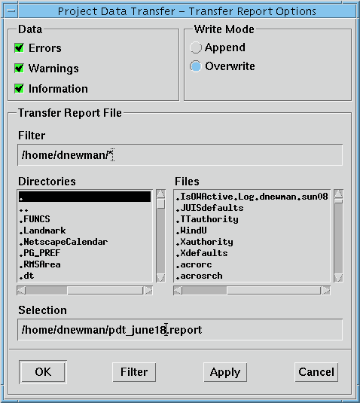

Once you have this information set, click on OK to exit the dialog box.

Now, go to the File → Save option, in the main PDT dialog box, and give the Configuration File a name. This will hold the parameters that you have just set in the above steps within PDT. Again, put this file in a particular directory so that you can access this information again in subsequent data backup/transfer runs.

Now it is time to select all of the data to be transferred. The recommended selections for this data transfer are:
Basin Data
Field Data
Well Data
2D Navigation Data (please talk to the data loaders in Calgary before selecting this data – to determine if it is necessary)
3D Navigation Data (please talk to the data loaders in Calgary before selecting this data)
Fault Data
Interpretation Data (if alternate office needs geological interpretation, grids, pointsets created by specific interpreters)
Line of Section Data (if alternate office needs geological interpretation by specific interpreters)
Well Template Data (if alternate office needs geological interpretation by specific interpreters)
Well Planning Project Data

To select each category, toggle on the category and click on the Options… box beside that category. Highlight each option in < > brackets and click on Select All for each list of data. Where there are no < > categories to select, you may need to select other available key words for highlighting or just use the Select All option. For the Well Data select <All Wells> in the upper left of the dialog box and continue in the same manner (you may need to scroll down to find this selection), clicking on Select All in all other portions of the dialog box.
It is not necessary to select any of the UNKNOWN fields, even though this may be the only selection option, since these are inherent to the tables within the database.
You can also control the amount of data being transferred by only selecting specific data within each of the Options… boxes that you know needs to be transferred. Also, you can generate transfers where the transfer only captures specific Interpreter data or type data. This can be done when these options are available in each of the data transfer dialog boxes. Just highlight the Interpreter initials or data types that you prefer to transfer.

In some cases, during this step, you may want to transfer all available data from the source project and then make decisions, once you reach the other office, on which data to retrieve from the PDT transfer. This may help avoid problems around not having all of the data that you need, but remember, once you start replacing data in an existing production project, you are altering that database – so be careful during any data transfer!

Once you have selected all necessary data to transfer, each data category within the main PDT dialog box will indicate how many of the existing selections are chosen. When you are satisfied with these selections, click on Controls → Transfer. This option will start the data transfer option from the source project (ORIENTE56) to the target project (TRANSFER_O56_*), writing any transfer information, errors, etc. to the reports that you have previously set up. Click on OK when PDT displays a summary of what is being transferred. The actual transfer is running only when you see a timing bar moving at the bottom of the dialog box.

Step 4: Backing up the Transfer Project
To backup an OpenWorks project, from the OpenWorks launcher, click on Project → Project Admin. Highlight the transfer project name from the list and select Project → Backup… For the Type of Backup, leave it on the default – Oracle and click on OK.

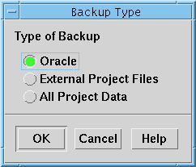

Within the “Project Administration: Oracle Backup” dialog box, click on the List… button across from File. Select an output directory and filename for the project backup. If you do not put an extension on the file name (<filename>.*), the backup option will automatically append a .dmp to the filename.

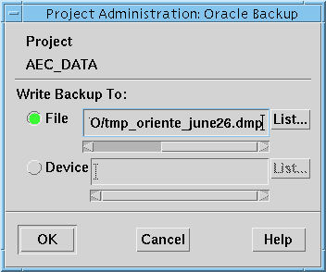

You may also write this data directly to a Device (backup tape drive), but it is a better method to write the backup out to a filename before putting it on tape. This can be considered a security measure just in case something goes wrong in the data transfer, you have the backup copy readily available for use. Plus, it may save critical time if the original tape transfer does not work properly.

Once the backup is complete, the dialog box will close and you will be returned to the Admprj (project administration) dialog box.

Follow the steps outlined in the section 3.2.1 o section 3.2.2 for either ftping the file or transferring the file to tape.

Online Data Restore

Step 1: Taking the Backup Files Off of Tape
Once the tapes have been transferred between offices, you will need to move the data from the tape to an area of disk space online to which Landmark has access. For files that you have ftp’d, it is only necessary to know where the files were placed during the ftp process. Then, you can continue on to section 5.2 of this workflow – Creating a Complete plist.dat File.

Insert the tape into the local DLT tape drive. Log into the UNIX box connected to the tape drive or another one that is on the same network. If you are logging into another machine that is on the network, but is not the one connected to the tape drive, type:

rsh <machine name with tape drive>

to access that machine directly.
If you are logging into a UNIX box through Exceed, be sure to select the machine name, when you log in, that is connected to the tape drive where your tape has physically been loaded.

When you are on the system connected to the tape drive, go to an xterminal window and type:

cd /data/transfer/CALGARY (in Calgary)
or
cd /data/transfer/QUITO (in Calgary)

When you are in this directory, check the disk space in this file system to make sure that you have enough space by typing:

df –k .

If there is not enough room to extract the files from tape, please contact the system administrator at the office, or another IT contact, to determine where available disk space can be found for the file extraction.

Find out the name / configuration information of your DLT tape drive by asking someone or checking on the physical tape drive for the configuration information; similar to how you determined the tape drive information in section 3.2.1. Using the same tar command that you used in section 3.2.1 while tarring the files onto tape, do the following. Type:

tar –xvf /dev/rmt/0

or

If there are multiple files on the same tape, the following command will take the first file off of the tape and will not rewind the tape:

tar –xvf /dev/rmt/0n

Once this file finishes unloading, type:

mt -fsf 1 /dev/rmt/0n

This command moves you past the end-of-file (E.O.F.) marker so that the machine can now “see” the next file on tape. The number 1 indicates the next end of file. After it reaches the next file and the green light is solid, simply retype the tar command above, using the no rewind option. For another example, if you wish to advance to a specific place on the tape like the fourth file type:

mt -fsf 3 /dev/rmt/0n

or

If multiple tapes and the tar –cvMf command was used to create the tapes, make sure that you have inserted tape #1 in the tape drive to start the job and type:

/usr/local/bin/tar –xvMf

Once the data from the first tape has completely unloaded, the computer will prompt you to insert the next tape into the tape drive for extraction. Once you have replaced the tape and the green light has stopped flashing, press enter to continue. Do this until all of the data from the tapes has been unloaded onto disk.

Once the process of tarring the files off of tape is complete, the tar command will return you to the prompt. Type:

ls –latr

to determine if the file(s) have been extracted properly from tape.

Step 2: Creating a Complete plist.dat File
Please make sure that a current plist.dat file is in place, which contains all of the projects from both offices, before the restore has started.

**NOTE: If project names are missing from the active plist.dat file at the office where you are doing the extraction, this data will not be taken off of the tar ball.

The plist.dat file holds information about each SeisWorks project, providing its name, create date, OpenWorks affiliation and master directory, in the case of 2D projects. This file is editable, but please make a backup of the original file(s) before any edits are done. Lines that are changed in this file can influence whether a SeisWorks project can be opened properly or not.

You can find the plist.dat file by opening a Landmark xterminal by clicking on System → UNIX Window. Type:

cd $OW_PMPATH

If this variable is not set, please type:

cd $OWHOME

Do a listing (ls) at this point and cd into the conf (configuration) directory.
Once you are in this directory, you will find the plist.dat file amongst other configuration files.

Copy the plist.dat file from the source to the target office by using the ftp command described in section 3.2.2. When doing this, put the file in the staging area, making sure that you do not overwrite the original plist.dat file. It may be a better practice to make a copy of the plist.dat file in the source office and renaming the copy, before ftping the file to make sure that no overwrites occur.

It is easiest to use the plist.dat file that has changed the most or is the largest, as the file to edit and save as the active file. Compare the two ascii files, from each office, by pulling them up on screen, side-by-side in an editor. To use nedit type:

nedit <filename>

Highlight missing lines from the comparison file and copy these lines to the main plist.dat file. Using most computers, even Solaris systems, and most editors, after you highlight a line, you can press the Ctrl and c keys on your keyboard, at the same time, to copy the line. Then, move your cursor to the file where you want to paste the line and press the Ctrl and v keys at the same time to paste the new information in this file. Alternatively, after highlighting a line, you can use the menu items, selecting Edit → Copy and then positioning your cursor in the other editor where you want to paste this line and click on Edit → Paste.

The plist.dat file is organized alphabetically by SeisWorks project name, so please add additional lines by putting them in the correct order. Make sure that you save this file to the correct location in the $OW_PMPATH directory structure, naming it plist.dat and not overwriting any existing files before continuing with this workflow. The active file must have the name plist.dat in order for Landmark to be able to read the file contents.

Step 3: Restoring the SeisWorks Data
**NOTE: Before this step is done, make sure that there is a recent online backup of the target online data in this office, that is readily available for use, if needed.

Once the data is on disk, you can start the data restore process. To do this, open a Landmark xterminal; Launch Landmark, click on System → Unix Window. Using this xterm, go to the directory where the script is stored by typing:

cd /home/encana/startup/intlR2003/SeisWorks_Download_Sync.sh (in Calgary)
or
/data/transfer/scripts/ SeisWorks_Download_Sync.sh (n Quito)

This will provide you with usage instructions that you can use to extract the files from the tar ball. They should be similar to the following:

SeisWorks_DownLoad_Sync script has required inputs

usage: SeisWorks_DownLoad_Sync <UnLoad Staging Location> <File Name of Compressed Backup tarfile> <DownLoad Option (ON) or (OFF)>

UnLoad Staging Location -----------> Valid Staging Area
where Download will be staged
File Name of Compressed Backup tarfile ----------> File name of
Compressed Tar Ball to DownLoad
& Synchronize
DownLoad Option
ON ----------> Trial DownLoad
Conducted without SeisWorks
Project Data Synchronized. Use
this Option if Test DownLoads
or Project Data Reviews are
required
OFF ----------> Actual Project
Data DownLoad & Synchronization
Conducted

**NOTE: Make sure that you are using the same version (date) of the script that was used for the data backup. You can determine if the files are of the same version by checking the date stamp on the file. If the date stamps are different, have the other office ftp the download script (or use the Citrix connection to transfer the file) that matches the script used for the data backup.

To check to see what data will be synchronized during the process or to compare data files, type:

/home/encana/startup/intlR2003/SeisWorks_Download_Sync.sh /data/transfer/staging /data/transfer/CALGARY/DEFAULT.<datestamp>.tar.Z ON (in Calgary)
or
/data/transfer/scripts/SeisWorks_Download_Sync.sh /data/transfer/staging /data/transfer/transfer/ecuador.<datestamp>.tar.Z ON (in Quito)

This above command will not remove the files from the directory.

To actually download the data from the tar ball, which will overwrite actual data on disk where it sees files of the same name within the project directories, type:

/home/encana/startup/intlR2003/SeisWorks_Download_Sync.sh /data/transfer/staging /data/transfer/CALGARY/DEFAULT.<datestamp>.tar.Z OFF (in Calgary)
or
/data/transfer/scripts/SeisWorks_Download_Sync.sh /data/transfer/staging /data/transfer/QUITO/ecuador.<datestamp>.tar.Z OFF (in Quito)

This command will start taking the data from the extracted file and will put it into the SeisWorks directories that are on your system. Also, once this command completes, the tar ball will be removed from your staging area on disk.

The staging area must be more than twice the size of the file that has been pulled off of tape (2.5 times is a good measure). For staging areas that need more than two gigabytes of disk space, please make sure that you are writing to a system disk that supports large files (see ONLINE DATA BACKUP AND RESTORE section Step 1: Backing up the SeisWorks Data for a description of how to determine this type of system disk). If there is not enough disk space set for the staging area, the file extraction will fail.

Online Download Assumptions

- The synchronization process will overwrite existing SeisWorks Project files
with the same UNIX file name.
- The synchronization process will abort if there is not enough on line SeisWorks
Project disk space to complete the download. Consult the error logs to determine
where the download failed. It is best to do a trial download to estimate
synchronization disk requirements.
- A synchronization or download staging area is required.
- By default, UNIX ownership of SeisWorks project files downloaded will be owned
by the user who conducts the download process. To inherit the UNIX
ownership of the SeisWorks project files downloaded the following must be
done. Conduct the download as root on the Data Server where the SeisWorks
project mount points are local. As well, ensure all affected Unix user accounts
are available via NIS or some other mechanism in the EnCana Quito and EnCana Calgary environments.
- The download must be run in a valid Landmark R2003 runtime environment
- A multi horizon import will be conducted for SeisWorks 3D projects in order
to synchronize with any project specific downloaded horizons_BCK.dat files.
- EnCana offices must have the multi horizon import utility (mltimp_SunOS) in place.
- Synchronization or Download Utility parameters required at invocation are:
  - Synchronization or Download Staging area
  - Name of Download Compressed Tar ball
  - The Report option
ON -→ Trial download conducted
OFF → Synchronization conducted

Restoring the Oracle (OpenWorks) Data

Step 1: Taking the Backup Oracle File Off of Tape

If the Oracle file is on tape follow the steps in section 5.1 to copy the data to an online directory.

Step 2: Restoring Oracle Project Data
**NOTE: Before this step is done, make sure that there is a recent online backup of the target OpenWorks project in this office, that is readily available for use, if needed.

To transfer the data to the existing Oracle project and instance, you must first put the transfer project online in the other office. To do this, make sure that you have OpenWorks running.

Once you have the OpenWorks menu bar on screen, click on Project → Project Admin. Click on Project → Restore… Leave the Type of Restore toggled on as Oracle and click OK. For the Restore Project Name, this will be the name that the project takes on in the new office environment. I suggest calling it something similar to the backed up project name (example, TRANSFER_O56_<date>).
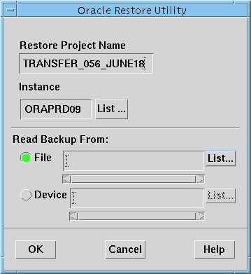

Since you have restored the file online, to a data directory on the system, under the Read Backup From section, select the List… key beside the words File. Select or type in the directory structure and file name of the Oracle backup that has been transferred off of tape or ftp’d to this office. When you have this information set, click on OK and OpenWorks will create a new project with the name provided above, under the Restore Project Name section.

Once this process is complete, again, it will return you back to the Admprj dialog box.

Step 3: Using Project Data Transfer (PDT) to Add Data to a Project.
Now, you will use the PDT process to move and overwrite/update data in the existing project that is online. So, please use caution and care when completing the following steps.

Set the TRANSFER_O56_* (restored) project as the active project in OpenWorks by clicking on Project → Project Change. When the Project Change dialog box is open, select the TRANSFER_O56_* project name and select OK. Launch PDT from the Project → Project Data Transfer option. You do not need to use the pdt –a script unless you need to transfer time-stamped data. If this is the case, please follow the procedure outlined in Section 4.4, Step 3 of this workflow. Within this dialog box, your source project should automatically be set as the TRANSFER_O56_* project. If it is not, select this project as your source project name by clicking on List…, highlighting the proper OWSYSID (Oracle Instance) and project name and pressing OK. Similarly, select your target project as the existing OpenWorks project at this office (example ORIENTE56). Once the project names are properly set, you will see the project displayed as <Oracle Instance name>.<OpenWorks Project Name> in the Project Data Transfer dialog box.

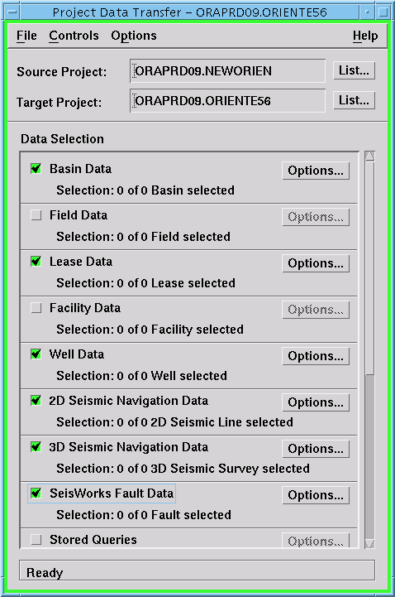

Select Options → Transfer Report Options and set a transfer report directory and unique, descriptive name to a known location, with enough online disk space and open write permissions, where this information will be safely captured during the data transfer. Make sure that all of the Data options of Errors, Warnings and Information are toggled on. Press OK to close this dialog box when this information is set.

Then select Options → Global Transfer Options. Toggle on the Overwrite Data in Target. Make sure that this is what you want to do. If not, the existing data will not be updated during the data transfer. Also, toggle on the Force transfer on conversion error. The data should already be using the proper coordinate system so there should be no conversion errors. If you are aware of bad data in the TRANSFER_O56_* project, you may wish to toggle this option off. Click on OK to close this dialog box.

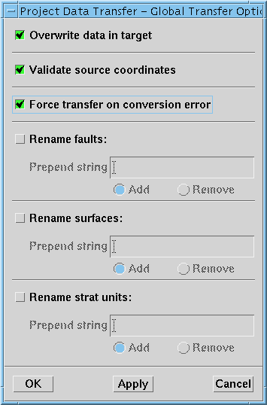

Now you are ready to go through the Data Selection portion of the Project data transfer dialog box and make sure that you select all of the data types that you want to overwrite / update in the existing online OpenWorks project. Only the data originally transferred from the Host office will be in this TRANSFER_O56_* OpenWorks project. If there is data missing from this project that is expected, please contact the Host office and have them redo the backup of this data, following the procedure in section 4 of this workflow.

Toggle on each data type and click on the associated Option… key. Select each type of data to be transferred, clicking on data names in < > and using the Select All keys for lists of data.

To transfer all data, you will still need to go into each data type option. Once you have selected all necessary data to be transferred, go down the Data Selection list and make sure that beside Selection, under each data type name, that the proper number of data selections have been made. For example, if you want all 30 piece of data under Basin Data to be selected, it should read “30 of 30 Basin selected”.

Once all of the data types have been selected and the data transfer report has been set, click on Controls → Transfer to update / overwrite data in the existing Target project.

Review the transfer report that you have set to determine if any data, that has been selected, was missed in this data transfer. If so, try to determine why this data was missed; the transfer report will normally provide you with this information. At this point, data may need to be transferred using an alternate method, such as data export, or you may need to check to see if the Overwrite option was correctly set within the Global Transfer Options dialog box.

Upon successful completion of this operation, all of the users should be able to continue on as usual. If new data is now available for them to use, you may want to provide an e-mail indicating that they can include this data in their interpretations.

Once you have completed this, be sure to fill in the details of the data restore in the shared Oracle and Online Data Transfer documents in Livelink.

Data Cleanup
There is a limited amount of disk space in both offices. Please make sure that after every successful transfer the temporary OpenWorks projects and online data files are deleted. Make sure that the transferred data is quality controlled and the transfer reports checked before removing the online transfer files.

Written by: Charlene Radons
Edited by: Deirdre Newman
EnCana Corporation, Calgary Office

